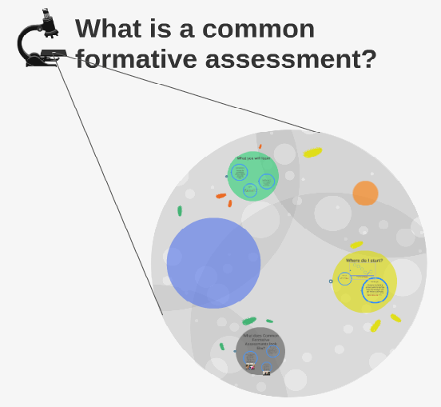It now well understood that highly effective teachers use data to fine-tune their instruction. Common formative assessments—tools that teams of teachers in a grade level or content area use to track student learning—produce especially vital data. As your school’s leaders, your team plays a crucial role in ensuring teachers can effectively use these tools. By gauging your teachers’ capacity to create and use common formative assessments, you can support those who need to build their skills.

**What Are Common Formative Assessments?**

*Formative assessments* are ongoing assessments that occur throughout the learning process. Tests and quizzes, are all forms of formative assessments. Research shows that when used in an ongoing fashion to provide timely feedback to teachers and students and to make instructional adjustments, formative assessments narrow achievement gaps and improve student achievement.

Teachers in a grade level or within a content area can increase the value of formative assessments and develop them more easily by working together to create or adapt existing *common formative assessments*. Doing so re quires teachers to collaborate and come to consensus on what content they will assess, how they will assess and

**How Do Teachers Use the Data from Common Formative Assessments?**

Many groups of teachers—by grade level, by content/department, and in other leadership teams—can use the results of common formative assessments to:

* Diagnose learning difficulties
* establish instructional goals for individual teachers, teams, and the school
* identify and share effective teaching strategies
* differentiate classroom instruction
* design professional development opportunities

**What Do Common Formative Assessments Look Like?**

Here are three examples of common formative assessment:

* Seventh grade English language arts teachers use district standards to develop common narrative, expository, and persuasive writing assignments and corresponding rubrics. Teachers share completed assignments to calibrate their use of the rubrics and to monitor students’ progress.
* Eighth grade math teachers all agree to administer portions of their curriculum’s end-of-unit tests. After the teachers score the tests, they meet to analyze the results and to develop necessary interventions for struggling students.
* Seventh grade science teachers develop and use common assessments that focus on the curricular content that eighth grade teachers have flagged as problematic for students entering their eighth grade year

**What Capacities Do Teachers Need to Effectively Use Common Formative Assessments?**

To effectively develop and use common formative assessments, teams of teachers need six essential capacities:

* **Appreciate the range of data important to impacting student achievement**

Rationale: Teachers can’t learn everything they need to know to improve their teaching from one data source. Data-literate schools use different kinds of data – some on a daily basis, some monthly or quarterly, and some annually – to sustain collaborative inquiry and continuously improve instruction. Common formative assessments represent an important part of this mix.

* **Articulate learning goals**

Rationale: A team needs to agree upon the key learning goals and sub-goals for a unit, assignment, or course prior to designing common formative assessments to measure students’ mastery of these goals. Learning goals should align with state, district, and/or school standards.

* **Design formative assessments**

Rationale: A team needs to learn how to craft quality formative assessments before it can effectively use these tools. Even if a team opts to use ready-made assessments, everyone on the team should know how to create one from scratch to tailor assessments to fit the team’s needs.

* **Analyze the results of common formative assessments**

Rationale: It is not enough to just create and use a common formative assessment. Teachers and teams need to know how to analyze the data to glean information about students’ progress and learning needs relative to the learning goals.

* **Use the results of common formative assessments to improve instruction**

Rationale: After analyzing data findings, teachers need to identify specific instructional responses to the data. Responses might include re-teaching content, changing instructional approaches to meet the needs of all students, or developing more challenging materials.

* **Embrace collaboration**

Rationale: Teachers must collaborate to create, use, and analyze common formative assessments. For a team’s use of formative assessments to be “common,” teachers need to agree on what they will teach, how they will assess content knowledge, and how they will collectively respond to the assessment data.

**REFLECT**